|  |  |
| --- | --- |
| **Project** | **Gym management system** |
| **Phase** | **02** |

1. **ERD Diagram**

Read this from top to bottom and left to right.

**Entities**

* Member
* Trainer
* Membership
* Class
* Equipment
* Attendance
* Payments
* Feedback
* Staff
* Supplier

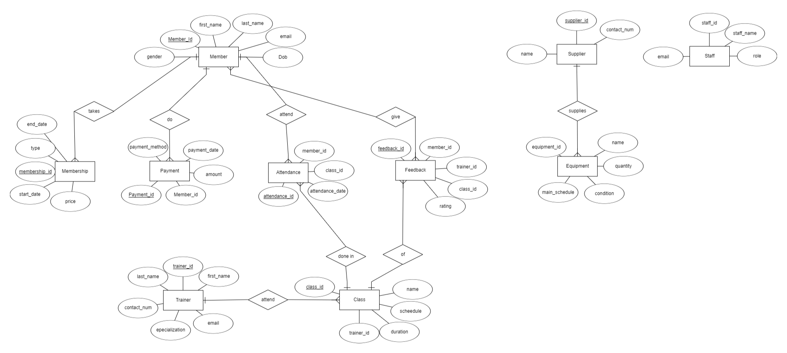

1. **Relational Schema Diagram**

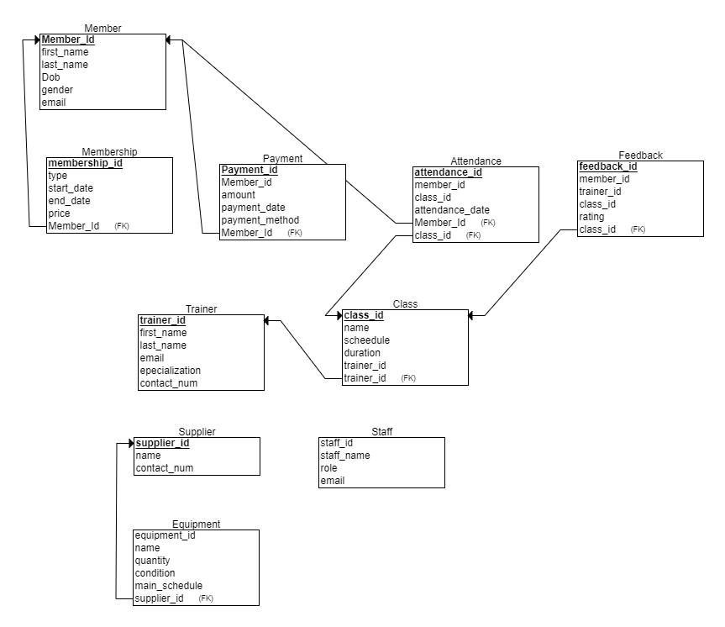

**Note: if these pics are seeing blurry, then go to my web to see them accurately by clicking this link:**

[**https://abubakartechy.github.io/DB-phase-2/**](https://abubakartechy.github.io/DB-phase-2/)